НАЦІОНАЛЬНИЙ АВІАЦІЙНИЙ УНІВЕРСИТЕТ

Кафедра інженерії програмного забезпечення

МОДУЛЬНА КОНТРОЛЬНА РОБОТА №__2_____

З дисціплини Data Bases

ВАРІАНТ №__13_

1. **Multivalued dependencies and 4NF. Examples**

What is Multi-valued Dependency?

A table is said to have multi-valued dependency, if the following conditions are true,

1. For a dependency A → B, if for a single value of A, multiple value of B exists, then the table may have multi-valued dependency.
2. Also, a table should have at-least 3 columns for it to have a multi-valued dependency.
3. And, for a relation R(A,B,C), if there is a multi-valued dependency between, A and B, then B and C should be independent of each other. If all these conditions are true for any relation(table), it is said to have multi-valued dependency.

Below we have a college enrolment table with columns s_id, course and hobby.

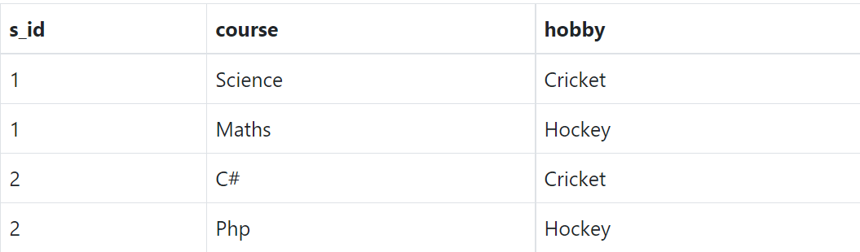

1. **What may be used in SELECT phrase when GROUP BY phrase present and absent?**

You must have SELECT privilege on each column used in a SELECT command. The use of FOR NO KEY UPDATE, FOR UPDATE, FOR SHARE or FOR KEY SHARE requires UPDATE privilege as well (for at least one column of each table so selected). A sub-SELECT can appear in the FROM clause. This acts as though its output were created as a temporary table for the duration of this single SELECT command. Note that the sub-SELECT must be surrounded by parentheses, and an alias must be provided for it. A [VALUES](https://www.postgresql.org/docs/9.5/sql-values.html) command can also be used here.

1. By using database from labs write expressions in SQL that answer to the following question:   
     
   Output week, day and lesson when the teacher Ivanov has lectures of type “lab” in group 308 of the 3rd course

Затверджено

Зав.кафедри __________________ М. Сидоров

(підпис)